Programming Assignment No: 03 (Class A)
Aim : To study Virtual functions & Polymorphism (Runtime Polymorphism)

Theory: Virtual Functions and Abstract Classes in C++
A virtual function is a member function in the base class that we expect to redefine in derived classes.
Basically, a virtual function is used in the base class in order to ensure that the function is overridden. This especially applies to cases where a pointer of base class points to an object of a derived class.
In C++, we can have the same function in the base class as well as its derived classes.
When we call the function using an object of the derived class, the function of the derived class is executed instead of the one in the base class.
So, different functions are executed depending on the object calling the function.
It's a runtime polymorphism because the function call is not resolved by the compiler, but it is resolved in the runtime instead.
In C++, we may not be able to override functions if we use a pointer of the base class to point to an object of the derived class.
Using virtual functions in the base class ensures that the function can be overridden in these cases.
This is known as function overriding in C++.
A pure virtual function is a virtual function in C++ for which we need not to write any function definition and only we have to declare it. It is declared by assigning 0 in the declaration.

An abstract class is a class in C++ which have at least one pure virtual function.
- Abstract class can have normal functions and variables along with a pure virtual function.
- Abstract class cannot be instantiated, but pointers and references of Abstract class type can be created.

[A]Write a C++ program to understand virtual function n C++
#include <iostream>
using namespace std;

class base {
public:
void A() { cout << "A->A\n"; }
virtual void B() { cout << "A->B\n"; }
virtual void C() { cout << "A->C\n"; }
void D() { cout << "A->D\n"; }
};

class derived : public base {
public:
void A() { cout <<"D->A \n"; }
void B(){ cout << "D->B\n"; }
void C(int x) { cout <<"D->C\n";
}
};

int main()
{ base *b1;
base b2;
b1 = &b2;
cout<<"Base functions is called"<<endl;
b1->A();
b1->B();
b1->C();
b1->D();
derived d;
b1 = &d;
cout<<"virtual(dervied functions is called)"<<endl;
b1->A();
b1->B();
b1->C();
b1->D();
}
OUTPUT:

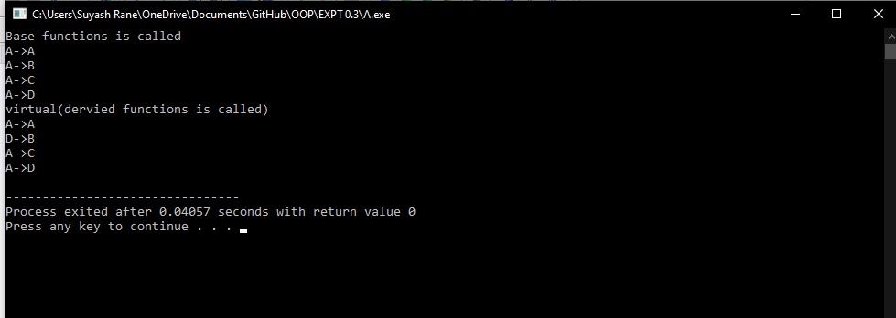

B]Write a C++ program to understand pure virtual functions in C++
#include<iostream>
using namespace std;
class Base
{
protected:
int x;
public:
virtual void fun() = 0;
Base(int i) { x = i; }
};
class Derived: public Base
{
int y;
public:
Derived(int i, int j):Base(i) { y = j; }
void fun() { cout << "x = " << x << ", y = " << y; }
};

int main()
{
Derived d(6, 3);
d.fun();
return 0;
}
OUTPUT:

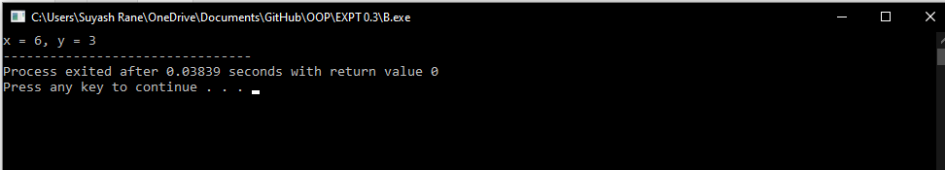
Conclusion
- Polymorphism allows us to create consistent code
- Abstract class can have normal functions and variables along with a pure virtual function.
- If an Abstract Class has derived class, they must implement all pure virtual functions, or else they will become Abstract too.
- We can’t create object of abstract class as we reserve a slot for a pure virtual
- Also, the Pure Virtual function must be defined outside the class definition. If you will define it inside the class definition, complier will give an error. Inline pure virtual definition is Illegal.

